Welcome to Skills Network Labs which you can access with [labs.cognitiveclass.ai](https://labs.cognitiveclass.ai/). On the Skills Network Labs homepage, you have all the data science tools at your fingertips. Once you're on the main page of Skills Network Labs, you'll find several buttons. Let's take a closer look at each of these building analytics tools.

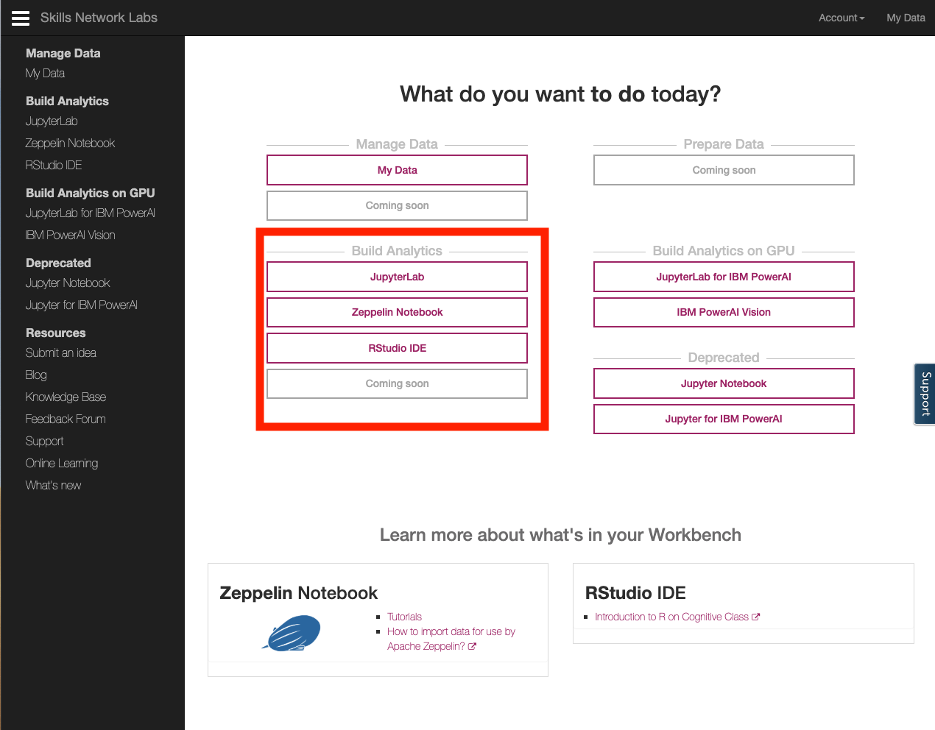

JupyterLab button takes you to JupyterLab which is an open source tool that provides an interactive environment to run or create notebooks that run codes in Python with Jupyter Notebooks, Scala on Apache Toree, R and other programming languages. In addition to notebooks, JupyterLab proviides, file browser to help you organize your files, console, terminal, GitHub integration and editors - functionality typically associated with Interacticve Sevelopment Environments (IDE). JupyterLab is an extensible environment and Skills Neetwork Labs is adding new functionality all the time.

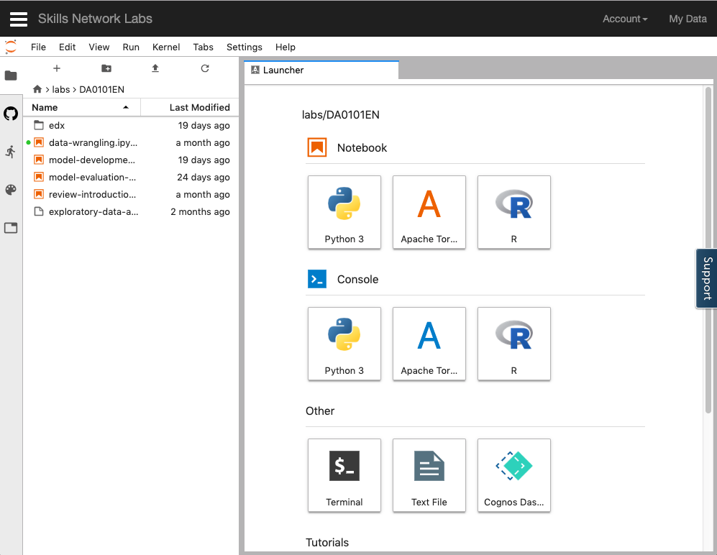

Notebooks are a favorite tool of many data scientists. Let's take a look at a Python 3 notebook. Jupyter notebook is an interactive document that allows you to execute code in smaller chunks called cells. When you execute a cell, the notebook prints any output immediately into the output cell. Doing so, allows you to do a number of things. For instance, you can write your code to import data, print the data, clean the data, print the cleaned data, create a model and print the model output and so on. And you can change the code in an input cell and rerun the cell as often as you'd like, but that's not all, the notebook also supports rendering markup cells in line, so that you can embed text, markdown HTML images, videos and even interactive widgets, all within a notebook.

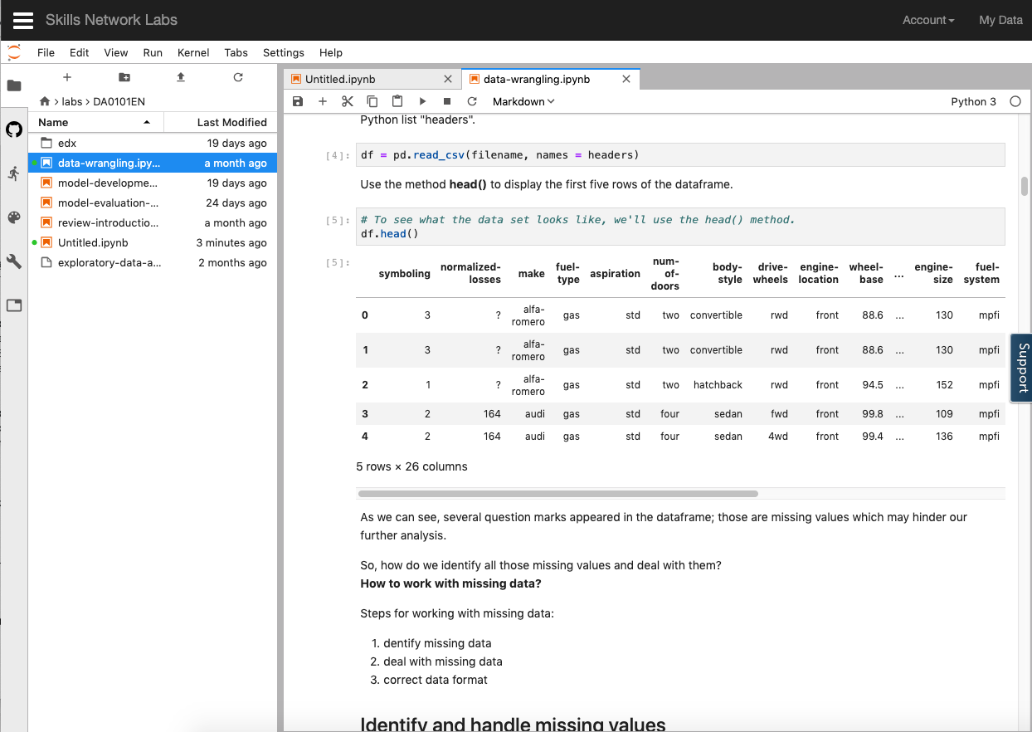

Let's look at another building analytics tool called Zeppelin Notebooks, Zeppelin notebooks allow Interactive Data Analytics. Like Jupyter, you use notebooks to ingest, discover analyze, visualize, and collaborate with your data.

Currently, Apache's Zeppelin supports many interpreters such as Apache Spark, Python, JDBC, Markdown and Shell.

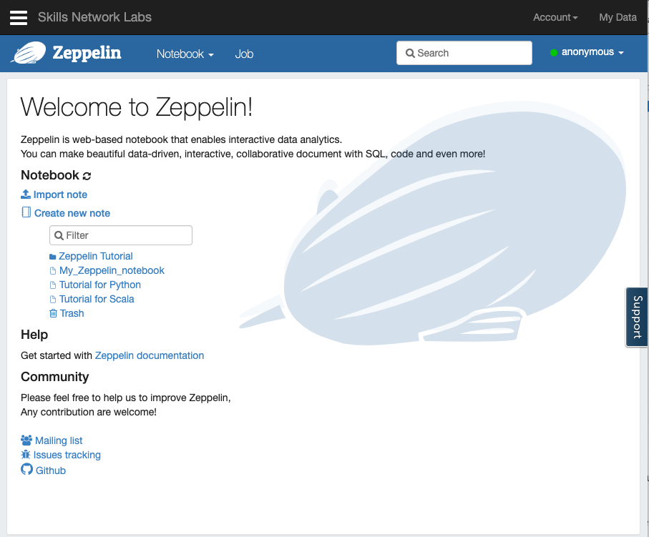

Let's look at Tutorial for Scala. Apache Zeppelin provides built-in Apache Spark integration so you don't need to build a separate module plugin or library for it. For data visualization, some basic charts are already included in Zeppelin allowing you to convert from data tables directly into visualizations without any code. Zeppelin also aggregates values and displays them in pivot charts, with simple drag and drop. You can easily create charts with multiple aggregated values including sum, count, average, minimum and maximum.

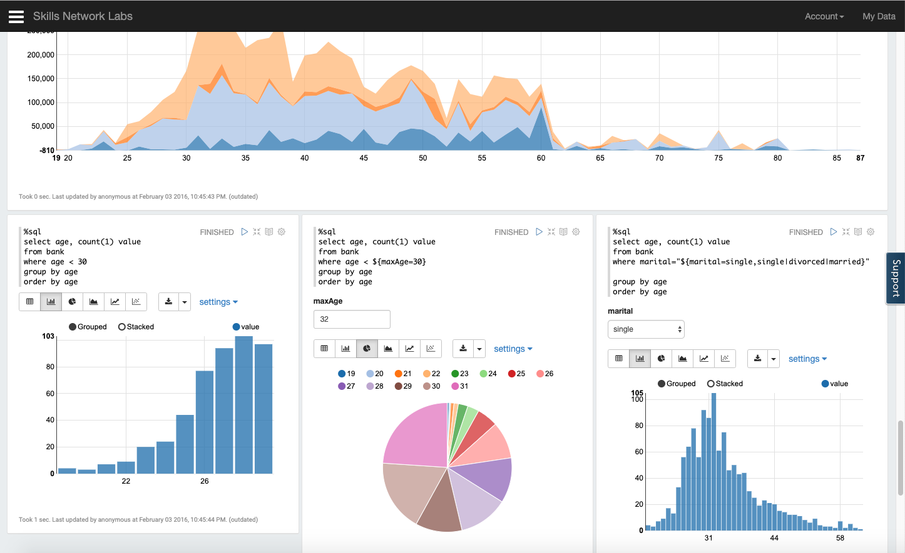

Finally let's look at RStudio in Building Analytics tools, RStudio IDE allows you to analyze data, take advantage of many statistical packages, create beautiful visualizations and Web applications. Like other IDEs, RStudio allows you to code in a console or a script editor as well as keep track of your variables and history. You can display your plots, manage your packages, and see help documentation for R. Taking it a step further, with R Shiny library, you can make your visualizations interactive. Using Shiny, you can create all sorts of Web based interactive apps just using R code.

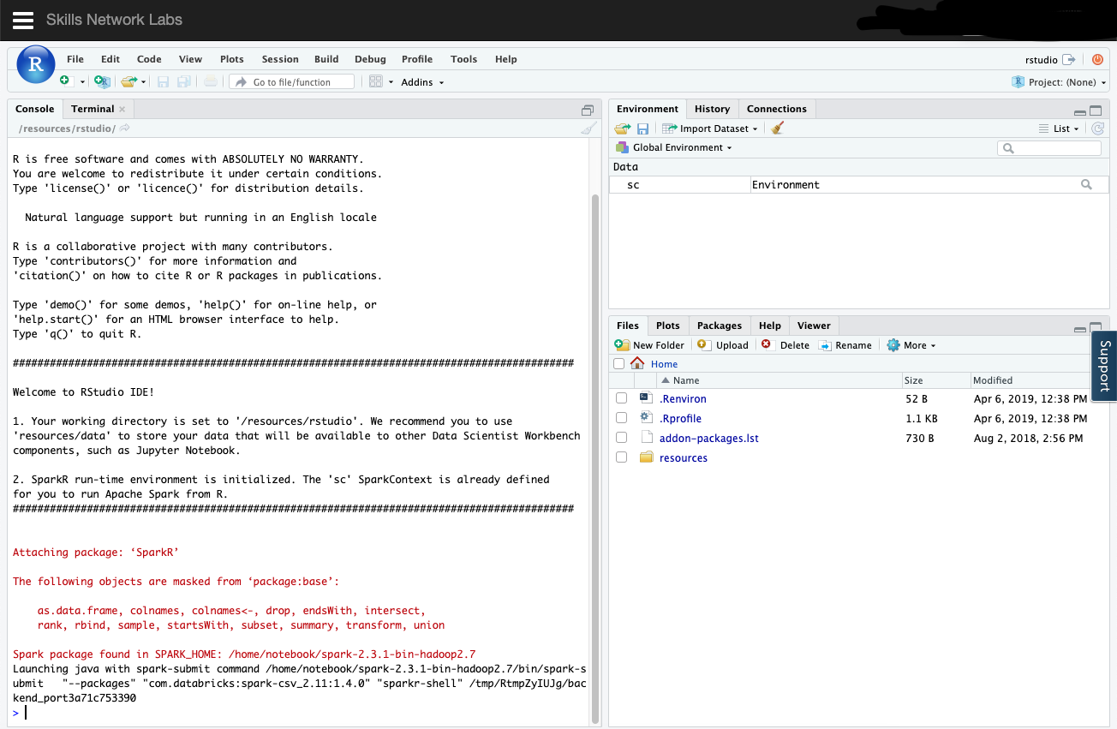

T